**IN NEED OF A LOVING HOME**

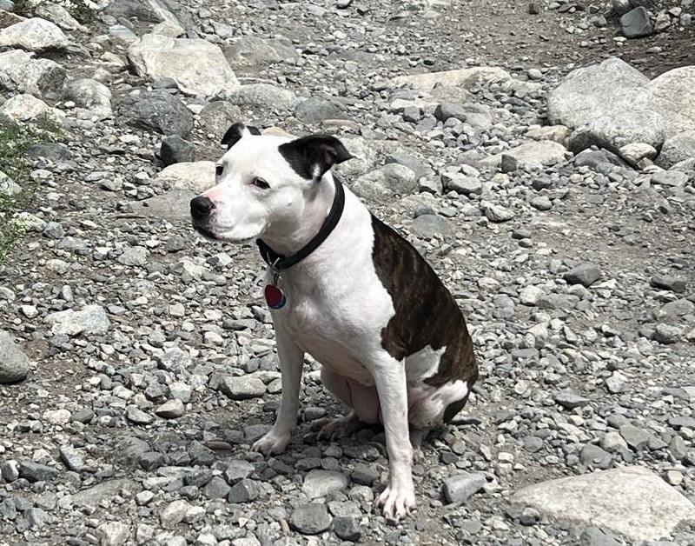

**LAYLA is in need of a loving family that will provide a comforting and stable environment.**

**She loves to cuddle as she thinks that she is a small dog. She also enjoys to run, play and hike. Layla is a loyal pit that will do anything to make her owners happy. She is great with kids of all ages but needs a home where she is the only pet. When it comes to paper, baby toys and small objects she will have the temptation to chew it. She also knows how to sit and will walk by your side on walks while on a leash, she will not drag you.**

**If interested, please contact Andrea DeMay at 315-882-2636. Please text first before calling.**

**Thank for your interest and support, it is greatly appreciated.**

**\*NOTE* I would prefer a homeowner that would allow me to still see her and have play dates with my baby.**